

MIDDLE EAST TECHNICAL UNIVERSITY

DEPARTMENT OF ELECTRICAL AND ELECTRONICS ENGINEERING

EE464 Term Project

Simulation Report

Group: The Isolated Ones

Selen Özge Özgür 2375566

Onat Şimşek 2375772

Onur Emirhan Con 2304384

**ABSTRACT............................................................................................................................. 3**

**INTRODUCTION & SPECIFICATIONS...................................................................................3**

**TOPOLOGY SELECTION....................................................................................................... 4**

**ANALYTICAL CALCULATIONS............................................................................................. 4**

**MAGNETIC DESIGN................................................................................................................**

**SIMULATION RESULTS..........................................................................................................6**

**COMPONENT SELECTION.................................................................................................. 16**

**MAGNETIC DESIGN..............................................................................................................17**

**REFERENCES.......................................................................................................................20**

**Appendix**

# ABSTRACT

To introduce the initial design of the Term Project for the EE464 Static Power Conversion II course, our group, The Isolated Ones, has compiled this simulation report. The primary objective of the term project is to create an isolated DC-DC battery charger. This report includes specified requirements, topology selection, simulation results, component selection and magnetic design.

# INTRODUCTION & SPECIFICATIONS

In this project, we are going to create isolated battery charger system from a DC source. This entails designing an DC-to-DC power converter circuit with the necessary control mechanisms. Since DC sources are not constant, we need to design a system that gives the same output voltage while the input voltage is changing. Design specifications are given below:

* Input Voltage: 20-40 V DC
* Output Voltage: 12 V
* Output Power: 60 W
* Output Voltage Peak-to-Peak Ripple: %3
* Line Regulation: %3
* Load Regulation: %3

# TOPOLOGY SELECTION

In this section, we are going to compare three topologies, which are flyback converter, forward converter, and push-pull converter to choose which topology we are going to use.

Comparison of the three converter topologies according to five different criteria is shown in Table 1. According to this table, even though the efficiency and voltage ripple of the flyback converter are worse compared to the other topologies, we chose the flyback converter topology because we won't be working with high power applications, and its lower cost and complexity are more important to us.

|  |  |  |  |  |  |
| --- | --- | --- | --- | --- | --- |
|  | **Efficiency** | **Output Ripple** | **Power Range** | **Complexity** | **Cost** |
| **Flyback Converter** | Moderate efficiency | Higher output ripple | Low to medium power | Least Complex | Cheapest |
| **Forward Converter** | Better efficiency | Lowest output ripple | Medium to high power | Medium Complexity | Medium |
| **Push-Pull Converter** | Can also have good efficiency | Moderate output ripple | Medium power | Most Complex | Most Expensive |

Table : Topology Comparison

# ANALYTICAL CALCULATIONS

From the previous experiences, we agreed that the most difficult part of this project to choose suitable control unit and control the switches. Due to that we fist choose a controller UC3845. We also find another controller LT3757, but it is much more expensive, so we decided to do calculations according to UC3845.

UC3845 can supply a duty cycle of 0.5 maximum, which gives us an upper boundary to choose our duty cycle. Hence, we have chosen a duty cycle range of 0.2 to 0.4. To ensure that the controller gives a duty cycle in this range, our turns ratio should be 1:1. This can be calculated as follows:

Due to the diode between the secondary side and the load, assume secondary voltage as 12.75V (= 12.75V) so that our output voltage is around 12V. Moreover, it is known that the voltage equation of a Flyback converter is as follows:

Where = 12.75 V, = 20-40 V. When = 20 and 𝑁2/ 𝑁1 ratio is taken as 1, is found as around 0.39. Furthermore, when = 40 and 𝑁2/𝑁1 ratio is taken as 1, is found as around 0.24.

For the transformer of the Flyback converter, we have selected an E-core with a gap of 1mm. The datasheet of the core can be found in the appendix section. An E-core is selected since the leakage flux in E cores is smaller than toroid cores due to their shape. Moreover, due to the existence of coil formers for each and every E-core, it is much easier to wind the coils to the core. Also, since we are to design a Flyback converter, the energy should be stored in the core first to transfer the energy to the secondary side. Hence, an E-core with a gap is required for us to implement a better solution to store the energy in the core when the switch is ON. Another reason for us to select this core is that it has a high permeability, even with the air gap, and it does not have a high volume, with a volume of 11.5 cm3, so that the core will not take up so much space in our final design. In order to find the required number of turns for both the primary and the secondary, which are the same for our design, we need to determine the magnetizing inductance value first. By using the magnetizing inductance formula in the Application Note, AN4137, Design Guidelines for Off-line Flyback Converters Using FPS [1], the magnetizing inductance can be calculated as follows:

where is the input power, which is selected as 72W to ensure an efficiency more that 80%, is the ripple factor, which is defined as in the Figure 1 and selected as 0.35. is the switching frequency, which was selected as 80 kHz. The core selection was done according to this frequency level. However, in order to decrease core losses, we decreased it to 80 kHz.

Figure 1. MOSFET Drain Current and Ripple Factor

After putting the values into the equation, is found to be 20.58 µH. Then, to find the required number of turns of the primary, the value of the core is used, and the required number of turns is found by using the following formula:

We have selected the core “B66363G0500X187” which is an N87 type ETD39 ferrite core from TDK Electronics, where value of the core we have selected having a 1mm of air gap is 196 nH/. Hence, after making the calculation, the required number of turns are found as 11, approximately. Moreover, by limiting the Bmax value, the minimum required number of turns can also be calculated to check whether the previously calculated number of turns is valid or not by using the formula present in [2] as follows:

where Bmax is selected as 0.2T, and effective area of the core we have selected is 125 mm2. When putting all the numbers to the equation above, it is found that minimum required number of turns should be larger than 7.77 turns (Nmin > 7.77 turns). This concludes that 11 turns in the primary and the secondary meet the requirement of minimum turns and can be used further in this design.

When the required number of turns is taken as 11, the inductance value of the primary winding can be calculated as 23.71 µH. Also, by knowing the relative permeability (µr = 115) and the effective length of the core (le = 92.2 mm), the actual magnetic flux density can be calculated by using the Ampere’s Circuital Law:

Where Imax is calculated as follows:

Then, Bmax, can be found as follows:

The value found is well below the saturation value of the used core, which is found to be 0.4T. Despite slightly increasing the core loss of the transformer, it has no effect on the design.

In order to determine the cable size in AWG system, the switching frequency and the current capability of the cable should be considered. Since our switching frequency is 80kHz and the RMS value of the current in the primary is around 9.5 A, a wire that can carry a current having these features should be selected. Also, when the skin depth is calculated using the equation , where the unit of the skin depth is mm, and skin depth is found as 0.265 mm. Thus, the selected cable should also have a radius smaller than 0.265mm and have a power transmission capability up to 107kHz, minimum. Hence, we selected a cable with a size of AWG 26. In order to carry the current in the primary and the secondary side of the transformer, more than 26 AWG26 size cables should be paralleled. Since one AWG26 cable can carry up to 0.361 A, the number of required cables is calculated as follows [3]:

One AWG26 cable has a cross section area of 0.128 mm2, but this value is taken as 0.14 mm2 by considering the insulation of the cables to have a more realistic calculation. Moreover, the window area of the used core is given as 178 mm2 in its datasheet. Hence, the fill factor can be calculated as follows:

Which is an acceptable value.

In order to calculate the copper losses of the transformer, the ohms per km value of the AWG26 cable, which is 133.8568/km is used to calculate the DC resistance of the cable. Also, the mean path length of the core is given in its datasheet as 69mm. Then, the DC resistance of the cable can be calculated as follows:

The AC resistance of the cable in 80kHz is calculated using the following formula:

where d is the diameter of the conductor. As can be seen from the resistance calculations, the DC resistance and the AC resistance are very close to each other. Hence, a higher value can be used to have a more robust calculation. Then, the copper losses in the conductor becomes:

The above equation is multiplied with 2 since RMS values in the primary and in the secondary are the same since the turns ratio of the transformer is 1.

As declared previously, the selected core is “B66363G0500X187” which is an N87 type ETD39 ferrite core. In its datasheet, the core loss graphs are given for different frequencies and for different magnetic flux densities for different temperatures. The core loss value for 80kHz is given as 300kW/m3, and also, the volume of the core is given as 11.5 mm2. Hence, the core loss of the transformer can be calculated as follows:

Then, the total losses on the transformer can be calculated as:

## RCD Clamp Design

The RCD clamp is to suppress voltage spikes generated during switching transitions, ensuring protection for sensitive components. By providing a path for energy recovery from the leakage inductance of the transformer it reduces voltage stress on the power switch. For calculating the we are going to use the formulas below. [4]

From the above equations, by putting Vmax=80V, Vin = 40V, fs = 80kHz, N = 1, Lleakage = 450nH, and Imax = 13A, which is found from the simulation results, R and C parameters found as; , .

# MAGNETIC DESIGN RESULTS

# At first, we planned to create our own litz wire by paralleling AWG26 cables, but when we realized that we couldn't wind it as tightly as we calculated during cable winding, we chose to use ready-made litz wire. We wound the transformer with 11 turns on the primary and 11 turns on the secondary. To minimize leakage inductance, we wound the primary and secondary wires in parallel. Primary winding inductance, and leakage inductance measurements are provided in Figure 2, Figure 3 respectively.

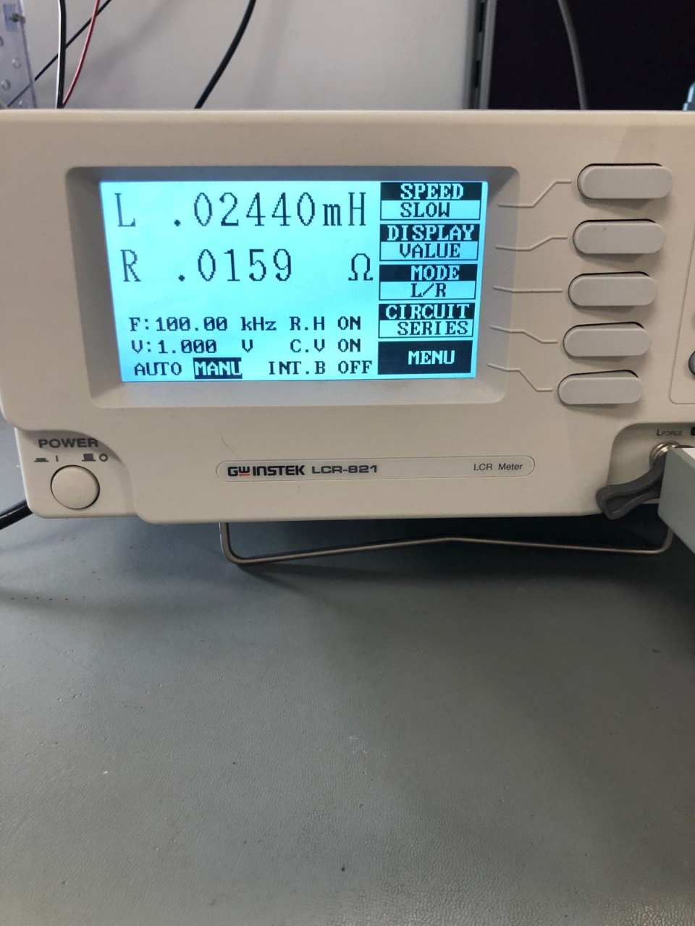

Figure 2.Primary Winding Inductance Figure 3.Leakage Inductance

# SIMULATION RESULTS

# To ensure the functionality of our design and choose components based on current and voltage readings, we conduct simulations using LTspice environment, incorporating non-idealities. Simulation schematic is given in Figure 4.

Figure 4. Simulation Schematic of Flyback Design

Figure 5. Output Voltage Waveform

Figure 6. Current passes through MOSFET (Blue) and D2 (Red) 40V input

Figure 7.Voltage Stress on MOSFET (Blue) and D2 (Red)

Figure 5 shows the output voltage characteristic. Output inductance (L2) and capacitances (C5, C9) output voltage is much smaller than %3 of output voltage. Current passes through MOSFET (Blue) and D2 (Red) can be seen from Figure 6. As we can see from these graphs, our circuit works in CCM. Furthermore, maximum current on MOSFET is 12A and on diode is 9A. From the Figure 7, we can get maximum voltage stress on both MOSFET and the diode. The MOSFET and the diode that we will select must have voltage range greater than 70 V and 60 V respectively.

Figure 8 shows the output voltage response to changing input. In the specifications of the project, line regulation must be below to %3 which means 0.36V. When we zoom in, we can see from Figure 9 that voltage does not go below 11.64V.

Figure 8. Output Voltage (Blue) Response to Changing Input Voltage (Green)

Figure 9. Output Response (Blue) when the Input Voltage (Green) Change

Figure 10 shows the output voltage response to changing load current. In the specifications of the project, load regulation must be below to %3 which means 0.36V. When we zoom into steady state value, we can see from Figure 11, voltage does not go below 11.64V.

Figure . Output Voltage (Green) Response to Changing Changing Load (Red) Current

Figure .Output Response (Green) when the Load Current (Red) Change

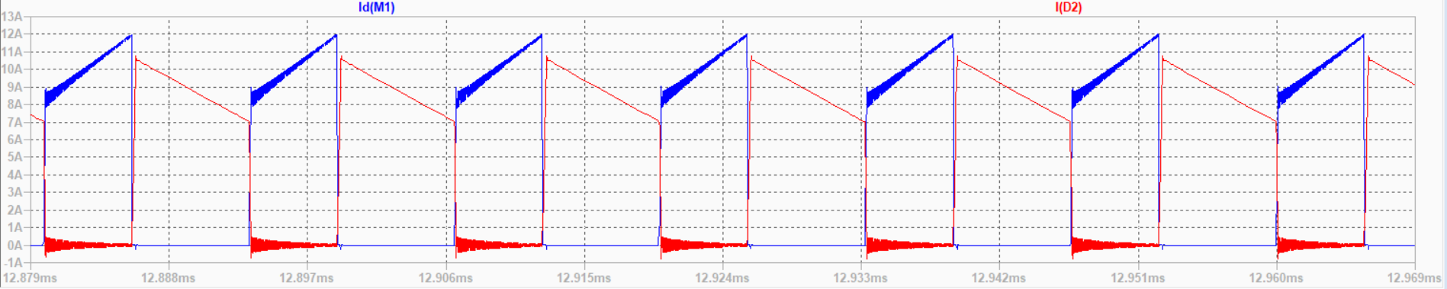

Figure 11. Current passes through MOSFET (Blue) and D2 (Red) for 20V input

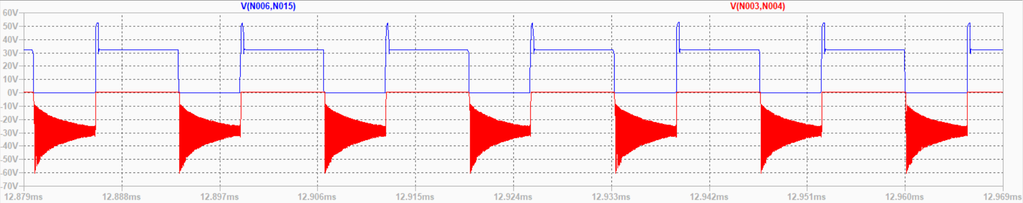

Figure 12. Voltage Stress on MOSFET (Blue) and D2 (Red)

According to the simulation results, when the input voltage is 40V, the output power is calculated as 59.57W, whereas the input power is 89.47W, which results in an efficiency of 67%. Moreover, when the input voltage is 20V, the output power is calculated as 59.5W, whereas the input power is 85.91W, which results in an efficiency of 69%.

# COMPONENT SELECTION

After the simulation results, we have an idea about what the voltage and current limitations of the components would be. We decided to use the following components after an extensive search.

For minimum input maximum load case transient current of the secondary diode reaches 24A and transient current of the RCD Snubber diode reaches the 22A. For the maximum input voltage maximum load case, transient reverse voltage of the secondary diode reaches 60V and the transient reverse voltage of the RCD snubber diode reaches 78V. Therefore, **DSA30I100PA** diode is chosen for both of them which has 30A current rating and 100V voltage rating.

For 40V input 85V and 26A is observed on the MOSFET during transient. For 20V input 65V 24A is observed on the MOSFET during transient. Therefore, **IRFZ540N** power MOSFET is chosen as the switching device which has 33A current rating and 100V voltage rating.

Since we decided to control our converter with **UC3845**, TL431 shunt regulator and **PC817** optocoupler are chosen for the control operation which are commonly used with UC3845.

There is an excessive power loss on the current sense resistor. Since UC3845 reads the voltage drop on this resistor we decided to use **ACS712-30** Current Sensor instead of a resistor.

# REFERENCES

[1]: AN-4137 Design Guidelines for Off-line Flyback Converters using FPS. Available at:

[AN-4137 Design Guidelines for Off-line Flyback Converters using FPS (dianyuan.com)](https://u.dianyuan.com/bbs/u/0/1071889497.pdf)

[2]: Single Transistor Forward Converter Design. Available at:

<https://ocw.metu.edu.tr/pluginfile.php/152997/mod_resource/content/0/forward_magnetic_design_recitation.pdf>

[3] Alferink, F. (n.d.). Average and effective values. Average and effective values: Electronic

Measurements. <https://meettechniek.info/compendium/average-effective.html>

[4]: RCD Clamp Circuit Design

[RCD Clamp (youtube.com)](https://www.youtube.com/watch?v=rmMYgnJ1oqE)

# APPENDIX

Link to core datasheet:

[Ferrites and accessories - ETD 39/20/13 - Core and accessories (tdk.com)](https://www.tdk-electronics.tdk.com/inf/80/db/fer/etd_39_20_13.pdf)

Link to core material datasheet:

[Ferrites and accessories - SIFERRIT material N87 (tdk.com)](https://www.tdk-electronics.tdk.com/download/528882/990c299b916e9f3eb7e44ad563b7f0b9/pdf-n87.pdf)